Refining the Approach to Process Flowsheet Development and Maturation at Hanford – 20049

Laura Cree*, Todd Wagnon*, and Stuart Arm**
*Washington River Protection Solutions
**Pacific Northwest National Laboratory

ABSTRACT

Rigorous process flowsheet management strategies form the basis of an enduring approach to refining the River Protection Project Integrated Process Flowsheet. Incorporation of lessons learned, recognizing upstream and downstream impacts and understanding barriers to implementation of process flowsheets from the outset of the decision-making process will help future revisions to the River Protection Project Integrated Process Flowsheet be more robust, technically defensible, cost effective, and time efficient, ultimately leading to an improved environmental stewardship of the Hanford site.

INTRODUCTION

In an effort to move the River Protection Project (RPP) mission at Hanford forward in an efficient, safe and cost-effective manner, the U.S. Department of Energy (DOE) has developed a phased construction and startup strategy for the Hanford Waste Treatment and Immobilization Plant (WTP). The phased strategy for cleanup of the 212 million liters (56 million gallons) of radioactive tank waste at the Hanford site begins with a direct-feed low-activity waste (DFLAW) concept in which cesium and solids are removed from the supernatant within the tank farms, prior to being fed directly to the WTP Low-Activity Waste Facility. As the tank farms and the WTP transition to this first operational phase, a need for process flowsheets as a tool that supports an operational culture of continuous improvement was identified and executed.

Process Flowsheets

In order to understand the significant tool that a process flowsheet represents, it is important to first understand the various parts necessary to a complete process flowsheet. Process flowsheets can be considered to have three main aspects: flow diagrams, mass and energy balances, and process control strategies. 1) Process flow diagrams depict interconnections of facilities, systems and components. They are useful for visualization of a process and its parts and to help understand the flow through a process. Process flow diagrams are also valuable communication tools and are used throughout this discussion to help illustrate the processes that are being discussed. 2) Mass and energy balances are used to account for material and energy flow through a system or process. These engineering tools use the application of the laws of conservation of mass and energy to ensure that all streams have been identified, that material and energy flow where desired, and that stream requirements (e.g. waste acceptance criteria and design requirements) are met. Examination of a process flow diagram and mass balance can aid in identifying pinch points, single points of failure, and non-value added operations. 3) Process control strategies describe how the system is to be operated and controlled to obtain the desired process performance and product quality. In other words, these strategies define the controls that need to be implemented in order for the system to meet its required throughput and make products that meet quality standards. These strategies should include information necessary to control processing of secondary waste streams as well, since it is undesirable for these streams to become the limiting factor in an operating process.

Development of the pieces of an integrated process flowsheet at Hanford is challenging in multiple ways. Most of the processes and facilities that will be used during the DFLAW phase of the RPP cleanup mission are new (e.g. WTP, Tank-Side Cesium Removal, etc.), or have never been operated as they will need to be during the DFLAW phase (e.g. Tank Farms, Effluent Treatment Facility, etc.). Compounding the challenge is the sheer magnitude of the task being undertaken. The RPP cleanup of the Hanford site is the largest and most complex environmental remediation project in the United States of America. Involved in the DFLAW phase alone there are four prime contractors, two DOE offices, and multiple smaller contractors and subcontractors. A very simplified flow diagram of the different pieces of DFLAW and how each prime contractor fits in is shown in Fig. 1.

Successful refinement of Hanford’s RPP Integrated Process Flowsheet involves a combination of definition, analysis, maturation and implementation of each aspect of the process flowsheet and its underlying processes, as well as the successful integration of each contractor. Process flowsheets were established by defining how the various facilities will be inter-connected and projecting material flows and their characteristics, documenting assumptions and the technical bases behind those assumptions, and identifying opportunities for future improvements. The process flowsheets are analyzed to identify candidate process control parameters. Maturation of the integrated process flowsheet involves realizing the opportunities through technical studies and laboratory work. Implementation takes the matured process flowsheets and candidate process control parameters to determine the process control strategy and what is needed from an infrastructure perspective, complete projects that support future operations, and incorporate plans into actual work schedules. At each step along the way, all involved parties need to be aware of where they fit into the integrated process and how changes that they implement to their own individual processes may impact downstream facilities.

DISCUSSION

Evolution of the RPP Integrated Flowsheet

Establishment of the RPP Integrated Flowsheet at Hanford began around the time of the decision to move forward with the DFLAW concept. An effort was made to build an integrated process flow diagram, including all inter-facility process streams that involved material flow from the hazardous chemical and radiological tank waste as it resides in the Hanford Tank Farms, through the vitrification process, all the way to the final disposition of all resultant secondary waste streams. The RPP mission was divided into multiple phases and an overall mass balance was developed for each phase. At the time of the first iteration of the Tank Waste Disposition Integrated Flowsheet [1] (re-named in later revisions to the RPP Integrated Flowsheet), 42 inter-facility DFLAW process streams had been identified, including 19 streams that will cross contractual boundaries. (These numbers have been updated to 58 DFLAW process streams and 21 that will cross contractual boundaries in more recent revisions to the flowsheet).

LEAN Management techniques were instituted, starting with a Value Stream Analysis (VSA) to determine which areas of the DFLAW process needed improvements and how those improvements could most effectively be initiated. The initial VSA effort involved individuals from both the Tank Farms Operating Contractor (Washington River Protection Solutions [WRPS]) and the WTP contractor (Bechtel National, Inc.), experts from Savannah River National Laboratory (SRNL) and Pacific Northwest National Laboratory (PNNL), and participants from the DOE’s Office of River Protection (ORP). The group identified seven Rapid Improvement Events (week-long workshops), one project and two Just-Do-Its (single contributor studies) that were performed to realize improvements identified in the DFLAW process.

Additionally, an independent review of the Integrated Flowsheet was performed by experts from Savannah River Remediation to provide assurance in the development and management of the Integrated Flowsheet effort. The team reviewed documents, conducted interviews, participated in the VSA outbrief, attended meetings related to schedules and integration activities. They identified 11 key opportunities for improvement, which were implemented to the fullest extent possible.
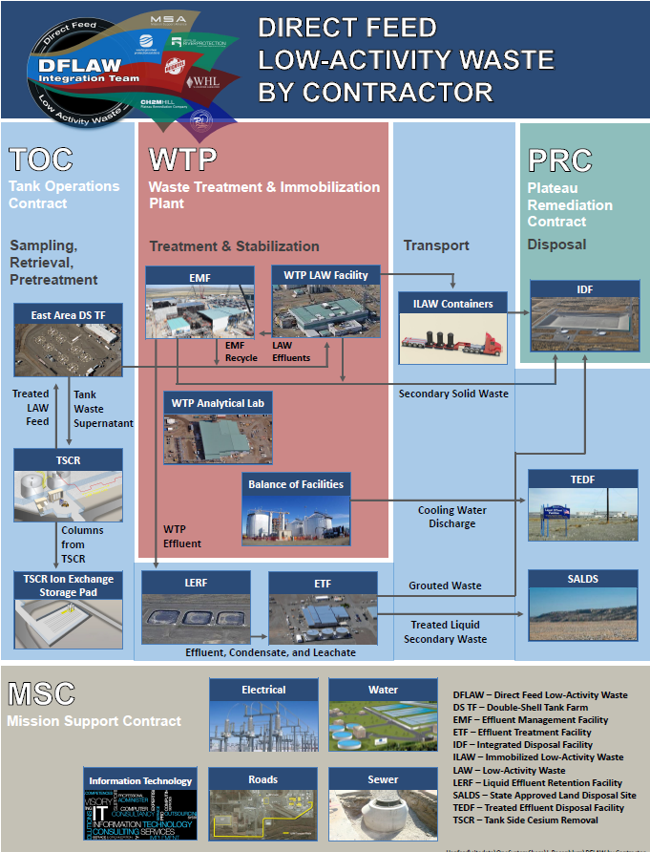
Fig. 1. DFLAW flow diagram showing the interactions of the prime contractors

As a result of both the independent review and the VSA, a revision to the RPP Integrated Flowsheet began. This revision included a major overhaul of the resulting document, focusing primarily on the DFLAW phase, and incorporating new sections that focused on the interfaces between facilities. A table of interface flow parameters (IFPs, individual parameters resulting from process control strategies) and the technical basis behind the IFPs was developed. A comparison of projected stream concentrations against known Waste Acceptance Criteria (WAC) was completed, and the utilization of the 242-A evaporator in Tank Farms, Effluent Treatment Facility (ETF) and Treated Effluent Disposal Facility were compared against permitting and technical capacity limits. The goal of these new analyses is to identify potential problems before they occur, allowing the various contractors time to mitigate issues and ultimately avoid schedule delays or increased operations costs. The WAC analysis was proven to be effective in the most recent revision of the report [2], as described in Case Study #1.

Case Study #1: Sr-90 Concentration Limits

In each revision of the RPP Integrated Flowsheet report a new flowsheet model run is performed to incorporate changes to the RPP mission and waste feed delivery strategy. Along with updates to the projected mass flow tables and the existing WAC comparisons, the most recent revision included the comparison of projected immobilized low-activity waste (ILAW) containers against the proposed WAC for the Integrated Disposal Facility (IDF) [3]. This stream is shown as a green arrow in the top right corner of the simplified process flow diagram depicted in Fig. 2.

While the analysis of projected ILAW containers against the proposed WAC for IDF was being performed, it was noted by the engineers performing the analysis that the projected Sr-90 concentrations were much higher than the proposed IDF limit. In past revisions of the RPP Integrated Flowsheet report [5,6], although an official WAC did not exist, ILAW container concentrations had been compared to WTP contract limits [7] and no such issue had been identified. The proposed WAC limit of 2.3 Ci/m³ was much lower than the WTP contract limit of 20 Ci/m³. At an average concentration of 4.3 Ci/m³, most of the projected ILAW containers would not meet the proposed WAC limit for Sr-90, but would meet WTP’s contract requirements.

Upon further probing, it was found that the proposed WAC was based on the IDF Performance Assessment [8], which had been performed based off of a previous revision of the RPP Integrated Flowsheet [5]. The Sr-90 limit was sufficiently high to account for ILAW containers projected in the outdated flowsheet model runs, but the Sr-90 solubility correlation used in the model had been updated and now predicted much higher Sr-90 concentrations in ILAW containers. The technical basis behind the solubility correlation is being examined, but in the meantime, the discrepancy between the WTP contract and proposed IDF WAC still existed.

All three of the affected contractors (WRPS, Bechtel and CHPRC) and DOE representatives from ORP and the Richland Operations Office (RL) were notified and a path forward was determined. An IDF Unreviewed Disposal Question Evaluation was submitted, and as part of the evaluation process, the IDF performance assessment was limited by the assumed institutional control period of 100 years. If DOE would agree to maintain institutional control of IDF until 2242, the performance assessment could be updated to include the 20 Ci/m³ limit for Sr-90. As part of this agreement, a new requirement has been added to the sitewide institutional control plan for Hanford [9] and updates to the performance assessment and WAC are already underway.

By involving all interested parties in the decision making process and bringing the issue to light as soon as it was identified by RPP Integrated Flowsheet engineers, the discrepancy was well underway to being resolved even before the updated flowsheet report was issued.

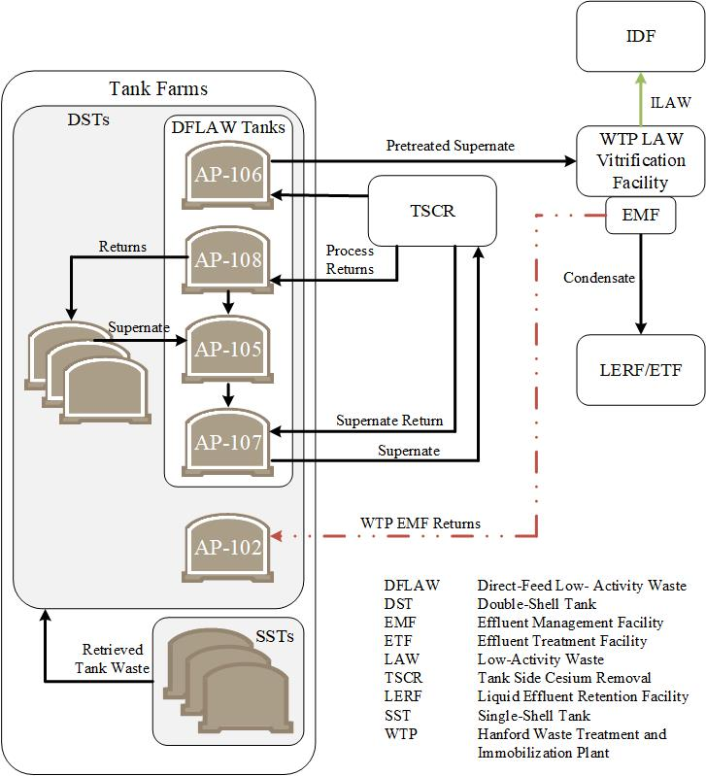
Fig. 2. Simplified DFLAW process flow diagram, adapted from RPP-40149-VOL2, Rev. 5 [4]

Through the RPP Integrated Flowsheet effort, gaps and opportunities have been identified and documented along with flowsheet maturation plans for how to close gaps and realize opportunities. Each year, gaps and opportunities are closed by technical efforts internal to WRPS and Bechtel, or by laboratory work and technical studies subcontracted to outside sources (e.g. SRNL, PNNL, Vitreous State Laboratory). An example of how the flowsheet maturation process has been used to improve the DFLAW flowsheet is described in Case Study #2.

Case Study #2: Corrosion Control Criteria across an Interface

One of the key underpinning concepts behind the RPP Integrated Flowsheet is clear communication of technical information that communicates the limitations and bases of data and incorporating the National Laboratories’ strengths for providing technical defensibility and continuity of scientific expertise. A good example of this concept concerns corrosion control criteria for the transfer of melter off-gas system effluent to the tank farm during the DFLAW mission (shown as a red dot-dashed arrow in the simplified process flow diagram in Fig. 2).

During the DFLAW mission, effluent from the SBS and WESP will normally be concentrated in the Effluent Management Facility evaporator and the concentrate will be recycled to the melters. However, flexibility is provided in the flowsheet by allowing for transfer of the effluent to the DST system to maintain melter operation while the evaporator is inoperable.

At the time the DFLAW flowsheet was being established, the DST corrosion control criteria were based purely on mitigating corrosion from a nitrate-rich concentrated salt solution, i.e. tank waste. Bechtel’s direct application of these criteria to the transfer of melter off-gas system effluent led to apparently reasonable additions of reagent. However, the effluent characteristics are very different from tank waste in being relatively dilute in nitrate salts but rich in chloride, fluoride and sulfate. These differences arise from the relative volatility of the halides and sulfate in the melter. Working with Bechtel, WRPS recognized that these characteristics meant the effluent presented a different corrosion mechanism (pitting) than tank waste and so a different mitigation approach was needed, although the same reagents are used.

One possibility was to adopt the criteria used at the Savannah River Site (SRS) to mitigate corrosion from Defense Waste Processing Facility effluent. However, the limited range of concentrations applicable for the SRS mitigation correlations meant an unreasonably large dilution was needed to bring the halide concentrations into the tested range. As a result, WRPS sponsored a program of work at SRNL to develop a mitigation approach that correlates the corrosion inhibitor (hydroxide and nitrite) concentrations needed for concentrations of corrosive constituents (predominantly halides). WRPS and Bechtel collaborated to define the range of concentrations expected in the effluent and, therefore, the applicable range of the correlation and design requirements for reagent delivery systems.

The corrosion mitigation requirements were formally established between Bechtel and WRPS in an Interface Control Document that receives concurrence from the contractors and ORP. Additionally, the tank farm contractor will be establishing a pitting corrosion mitigation requirement on intra-tank farm transfers to address a separate issue. The correlation developed for the WTP effluent contributes to the basis for the new tank farm requirement. Once established, the same requirement will be used for the WTP effluent and communicated using the Interface Control Document. Projections show the new universal requirement does not present any challenges for the WTP in terms of reagent delivery.

During process flowsheet development and maturation, computer simulations are powerful tools that can be put to many uses, including: building mass balances, examining flowsheet alternatives, and studying the interaction between disparate parts of a flowsheet. WRPS utilizes spreadsheets, life cycle models, process chemistry models and computational fluid dynamics models to explore different facets of the RPP Integrated Flowsheet. Each model has its own benefits, as well as limitations. Understanding the bases and assumptions that are inherent in each model, as well as how the process requirements have been interpreted and implemented are extremely important. In an environment where aging tank requirements are being used to bound new chemical processes, it is increasingly essential to include in the decision making process those who are most knowledgeable on the systems and requirements being utilized. This means bringing in subject matter experts, designers and operators to help ensure the efficacy of the flowsheet models being utilized. An example of how involving corrosion and mixing experts to develop a path forward for repurposing a DST to hold TSCR-treated supernatant is provided in Case Study #3.

Case Study #3: Repurposing of a DST

From initial conception to implementation, the strategy for repurposing a HLW storage vessel to support mixed LLW storage has evolved considerably. Initial concepts included multiple tank transfer and mixing evolutions to take advantage of serial dilutions to achieve the necessary decontamination and removal of the initial supernatant. The serial dilution strategy was drafted into an individual process flowsheet describing the proposed repurposing process.

Early questions were raised on the process flowsheet as to actual behavior of the supernatant below the pump inlet during decant and recirculation activities. Previous mixing studies had focused on the bulk behavior within double shell tanks and had not looked at the behavior of individual segments. These studies had shown that supernatant layers with a specific gravity difference of greater than 0.2 g/mL tended not to mix unless forced [10]. The process flowsheet was matured to take advantage of this observed behavior.

Opportunities were investigated to add a much denser 50 weight percent sodium hydroxide (caustic) to the tank bottom to “lift” the existing supernatant by displacement with the heavier caustic. This dense solution was within the established tank farm corrosion specification but was questioned when proposed to a wider audience. In the previous case, difficulties were raised based on the physical limitations of the system and its operating parameters. In this case, while the material to be added was within the existing tolerances, it was never envisioned to be directly placed against the tank surface and with little potential for mixing to occur. The written requirements did not provide the necessary background understanding needed to influence the process parameters. In both cases it was crucial to involve outside subject matter expert groups in maturing the flowsheet to ensure risks were appropriately captured.

Rigorous fluid mechanical modeling [11] and laboratory testing [12] were performed of both the mixing behavior and the corrosion impacts. The process flowsheet was updated, and a process control strategy was subsequently developed for field implementation that used pieces from both the initial and later concepts and mitigated concerns from all parties. The collective knowledge was improved relative to these aspects, which will inform and help shape future endeavors.

As the RPP Integrated Flowsheet has matured, it was recognized that in order to be effective, the process flowsheet needed to be executable in the field. A well-defined flowsheet without a path to implementation is a good exercise in chemistry and thermodynamics, but has little impact on overall objectives. Too often the developers of process flowsheets are removed from the physical constraints of the systems and facilities in which they operate. While this allows for creative problem solving and approaches it is limited when faced with real world constraints such as adequate footprint, power availability, and regulatory or external stakeholder limitations. A successful process flowsheet carries not only sound technical underpinning, but also an understanding of the system in which it is to be implemented and acknowledgement of the requirements and constraints of that system. An example of how working with project and operations teams improved the viability of the RPP Integrated Flowsheet is discussed in Case Study #4.

Case Study #4: Selection of Double-Shell Tanks to Support DFLAW

As part of the early business case analysis supporting the DFLAW mission, lifecycle modeling was performed to balance to demand on double-shell tank (DST) space, DFLAW needs, and other RPP mission priorities. The lifecycle model that was used simulated tank volume and chemistry and, using a prescribed set of near term transfers and activities, presented results which informed early assumptions for the DFLAW mission.

During this early work, five DSTs were identified to support various functions within the DFLAW mission. This early selection was based on projected available space and chemistry compatibility at the time of DFLAW start up. While these are clearly important constraints, engagement with operations and project teams quickly identified physical constraints and limitations within the model-defined plan, which could be easily avoided if a different selection scheme was implemented.

In this case the lifecycle model provided a tank selected for frequent returns from the processing facility (AW-106) which required a difficult transfer route and would result in increased availability demands of the transfer system (the transfer route is approximated in Fig. 3). Some increase in transfer system availability was expected during the transition to operations, but since the model was provided a prescribed set of activities, alternatives had not initially been explored. Engagement with projects and operations teams identified the physical constraints and limitations of the transfer system, and a second, more formal, tank selection alternatives analysis was initiated. This second evaluation included key input from the process flowsheet organization but also addressed critical field implementation and operability impacts which allowed for an improved tank selection (the improved transfer route is approximated in Fig. 4). As the DFLAW flowsheet has been updated to eliminate the need for a cesium eluate returns tank due to the move to a non-elutable ion exchange resin, the tanks chosen to support DFLAW have varied only in their purpose due to this second, more robust, tank selection process.

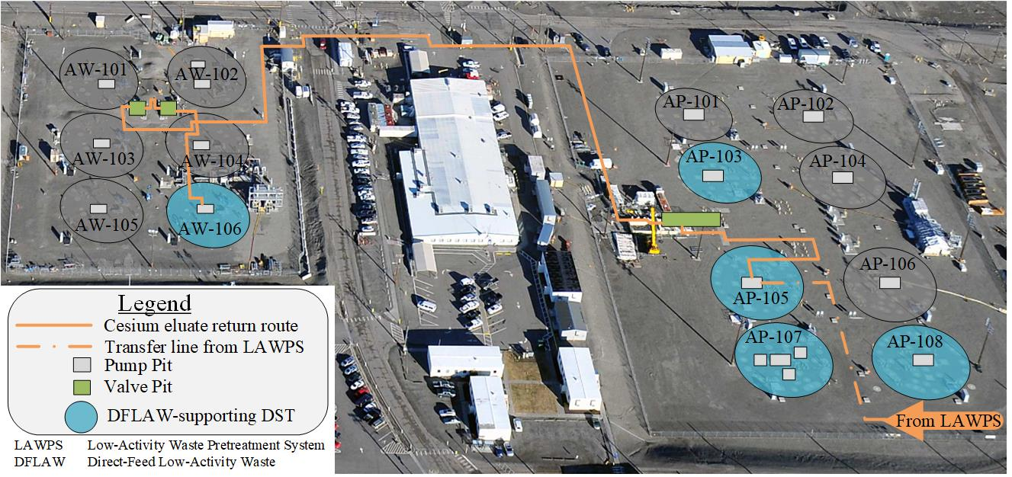
Fig. 3. Approximation of the initial transfer path for DFLAW cesium eluate returns to AW-106 overlaid onto an aerial picture of AW and AP Tank Farms at Hanford

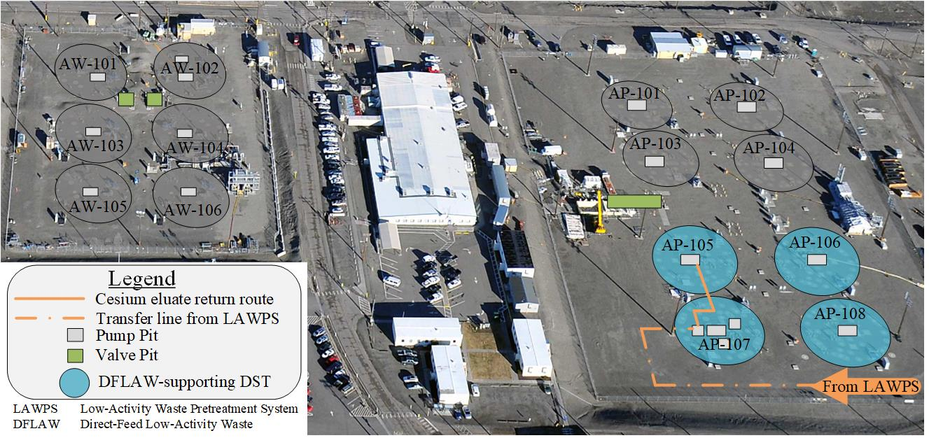
Fig. 4. Approximation of the optimized path for cesium eluate returns to AP-105 overlaid onto an aerial picture of AP and AW Tank Farms at Hanford.

Future of the RPP Integrated Flowsheet

As planning progresses beyond the start-up of the DFLAW phase that has been the focus for the past six years, opportunities to improve the efficiency of the RPP mission are being examined. Improvements to the post-hot commissioning stage of DFLAW are being considered. First principles chemistry models of important facilities (TSCR, WTP LAW, EMF and ETF) have been/are being developed. The models will not only be used to determine viability of TSCR waste feed campaigns prior to staging, but also to examine downstream impacts of selected feed campaigns and possible changes to process control parameters.

Gaps and opportunities in various stages of being identified, studied and closed are in the process of being documented in a database to make it easier to share information, make updates, add new entries and track old ones. This new database will be an important management tool during operations, enabling issues and opportunities for improvement to be efficiently identified and addressed. The database also serves as a valuable communication tool as gaps and opportunities are developed for later stages of the RPP mission.

Lessons learned from development of the DFLAW process flowsheet are being incorporated in planning for future stages. These lessons include: the early identification and closure of major flowsheet gaps, examination of interfaces and interface requirements for compatibility (as well as identifying where requirements need to be developed), and involvement of subject matter experts, projects and operations teams early and often in the planning process. Lessons learned from projects at other sites, like those from Tank Closure Cesium Removal and the Savannah River Site are also being incorporated into current and future planning.

As the RPP mission evolves new lessons will be learned and it is likely that new processes will be proposed to improve the mission duration or optimize the cost. The integrated process flowsheet is a vital tool for evaluation of those new processes or approaches by the very nature of how it drives a look across the process interfaces. The established flowsheet provides a baseline whereby other alternatives can be assessed in terms of both upstream and downstream impacts. Alternatives evaluations and an honest, objective assessment of the gaps involved in new processes will enable decision makers and stakeholders to make risk-informed decisions about the future of the RPP mission.

For each proposed update in the RPP Integrated Flowsheet it is vital that both upstream and downstream impacts be identified and communicated. With the complexity of the waste cleanup mission at Hanford, and multiple contractors working daily to improve their own processes, continued integration and open communication will be increasingly important to the success of the RPP mission.

Conclusion

In the commercial chemical process industry, process flowsheets form the foundation of process design and operations and, consequently, business success. At Hanford, project delays due to technical challenges have driven an increased cost and duration of the full RPP mission. However, a rigorous integrated process flowsheet management process is proving essential in establishing the foundation for waste treatment operations at Hanford and a mechanism to evaluate process flowsheet alternatives to improve the efficiency of the RPP mission.

Understanding end-state requirements and physical, political, economic and permitting barriers to implementation from the beginning stages of defining or refining a process flowsheet is paramount to avoiding unanticipated schedule delays and project costs. If gaps exist in the knowledge of these areas it should be known from the early stages and considered when weighing different process flowsheet options. Gaps which may result in fundamental shifts or changes in the flowsheet should be identified and worked to closure early on. As the DFLAW flowsheet is finalized it is crucial to maintain a questioning attitude and continue to challenge identified gaps and assumptions used in the flowsheet. The maturation of the flowsheet adds to the technical rigor and robustness of the final process.

Rigorous process flowsheet management strategies form the basis of an enduring approach to refining the RPP Integrated Process Flowsheet. Incorporation of lessons learned, recognizing upstream and downstream impacts and understanding barriers to implementation of process flowsheets from the outset of the decision-making process will help future revisions to the RPP Integrated Process Flowsheet be more robust, technically defensible, cost effective, and time efficient, ultimately leading to an improved environmental stewardship of the Hanford site.

References

[1] Arm, S., Colby, J., Fountain, M., Nguyen, V., Russell, R., Sasaki, L., Stone, M., RPP-RPT-57991, Rev. 0, “One System: Tank Waste Disposition Integrated Flowsheet – River Protection Project Reference Integrated Flowsheet,” 2014, Washington River Protection Solutions, LLC.

[2] Cree, L., Kimura, C., Nguyen, V., Randall, S., Tardiff, B., RPP-RPT-57991, Rev. 3, “River Protection Project Integrated Flowsheet,” 2019, Washington River Protection Solutions, LLC.

[3] Borlaug, W., IDF-00002, DRAFT, “Waste Acceptance Criteria for the Integrated Disposal Facility,” 2019, CH2M HILL Plateau Remediation Company.

[4] Orme, R., RPP-40149-VOL2, Rev. 5A, “Integrated Waste Feed Delivery Plan: Volume 2 – Campaign Plan,” 2019, Washington River Protection Solutions.

[5] Arm, S., Claghorn, R., Colby, J., Cree, L., Fountain, M., Nelson, D., Nguyen, V., Russell, R., Stone, M., RPP-RPT-57991, Rev. 1, “One System River Protection Project Integrated Flowsheet,” 2015, Washington River Protection Solutions, LLC.

[6] Anderson, K., Britton, M., Colby, J., Cree, L., Fountain, M., Nelson, D., Nguyen, V., Stone, M, RPP-RPT-57991, Rev. 2, “One System River Protection Project Integrated Flowsheet,” 2017, Washington River Protection Solutions, LLC.

[7] DE-AC27-01RV14136, “Design, Construction, and Commissioning of the Hanford Tank Waste Treatment and Immobilization Plant,” modified through No. M 451, 2019, Bechtel National, Inc.

[8] Lee, K., et al, RPP-RPT-59958, Rev. 1A, “Performance Assessment for the Integrated Disposal Facility, Hanford Site, Washington,” 2019, Washington River Protection Solutions, LLC and Intera, Inc.

[9] Ranade, D. DOE/RL-2001-41, Rev. 6, “Sitewide Institutional Controls Plan for Hanford CERCLA Response Actions and RCRA Corrective Actions,” 2013, Mission Support Alliance.

[10] Connor, J., Murray, R, RPP-RPT-60162, “Hanford Double-Shell Tank Supernatant Mixing: Activities, Observations, and Modeling,” 2017, Washington River Protection Solutions, LLC.

[11] Wells B., Recknagle, K., Suffield, S., Enderlin, C., Bottenus, C., and Fountain, M., LTR-OSIF-006, “Analytical and CFD Model Evaluation of AP-106 Liquid Heel Retrieval, and Mixing Operations,” 2019, Pacific Northwest National Laboratory.

[12] Weirsma, B., SRNL-STI-2019-00439, “Corrosion Evaluation for Tank 241-AP-106 Re-purposing,” 2019, Savannah River National Laboratory.

